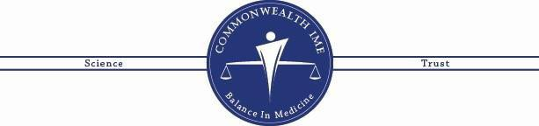

# Medical Director

Jeffrey N. Fadel, MD

**Vice President of Development** Jeremy Leitner

**Office Coordinator EDUCATION:**

**CURRICULUM VITAE**

## Clair Palley, M.D.

Bryan Dietsche • Monash University - Bachelor of Nursing 1990 - 1992

* Deakin University - Graduate Diploma of Human Nutrition

1995 - 1999

* University of Kentucky College of Medicine - Medical Doctor

2000 - 2 004

## POST GRADUATE:

* University of Kentucky College of Medicine - Family Medicine Residency 2003 - 2006

## EMPLOYMENT HISTORY:

* Madison Family Clinic - Medical Doctor, Medical Director

2006 - 2009

* Winchester Medical Associates - Medical Doctor

2009 - 2013

* CHI St Joseph Medical Group - Medical Doctor

2013 - 2023

* Alliance Personalized Health Care - Owner, Medical Doctor

2023 - Current

## TEACHING AND PRECEPTING EXPERIENCE:

* Preceptor for Medical Students, PA and ARNP Students 2006 - 2023

## MEDICAL LICENSES:

* Kentucky # 40160 – Active

**BOARD CERTIFICATION:**

* Diplomate of the American Board of Family Medicine, initially certified in 2006

# 9900 Corporate Campus Dr #2400  Louisville, Ky. 40222  502.554.9231 [customerservice@commonwealthime.com](mailto:customerservice@commonwealthime.com)

Clair Palley, M.D. Curriculum Vitae Page Two

## COMMITTEE WORK:

* President, Medical Executive Committee - Continuing Care Hospital at St Joseph Hospital

2012 - 2014

* Committee Member, Medical Executive Committee - Continuing Care Hospital at St Joseph Hospital

2011 - 2012

* Education Committee, St Joseph Hospital 2011-2015
* Transition Care Committee for QIP ACO 2012 - 2013